Lab # 4
ADALINE (Adaptive Linear Neuron)

OBJECTIVE

To understand and implement the ADALINE (Adaptive Linear Neuron) algorithm, train it using a simple dataset, and evaluate its performance in regression and classification tasks.

THEORY

Practical Significance:
ADALINE is an early type of neural network proposed by Bernard Widrow and Marcian Hoff in the 1960s. Unlike the perceptron, ADALINE uses a linear activation function and adjusts its weights based on minimizing the mean squared error. This approach helps in understanding the concepts of linear regression and the foundation for more complex neural networks.

Minimum Theoretical Background:

ADALINE Model Structure:
Similar to the perceptron but uses a linear activation function.

Mathematical Model:
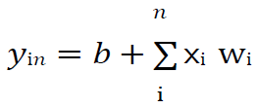
Here ‘b’ is bias and ‘n’ is the total number of input neurons.

Apply the following activation function to obtain the final output:

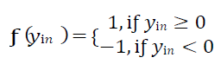

Adjust the weight and bias as follows:

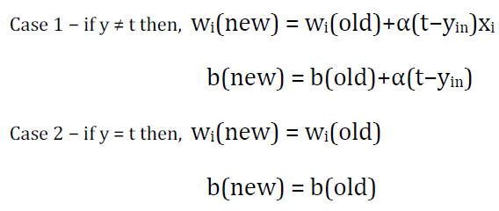

Here ‘y’ is the actual output and ‘t’ is the desired/target output. (t−yin) is the computed error.

LAB TASKS

- Implement the ADALINE Algorithm:

Train on Linearly Separable Data:
- Create or use a simple dataset (OR gate, AND gate, NOR gate, NAND gate).
- Train the ADALINE on this dataset and evaluate its performance.

Visualize the Cost Function:
- Plot the cost function against the number of epochs to observe the convergence of the algorithm.

Experiment with Different Learning Rates:
- Train the ADALINE with different learning rates and observe the impact on the training process and accuracy.

LAB OUTCOMES

This lab provides hands-on experience with the ADALINE algorithm. By implementing and experimenting with ADALINE, students will understand the concepts of linear regression, the importance of learning rate, and the behavior of the cost function during training. This foundational knowledge is essential for building more complex neural network models.

